Topic 8 / Chapter 8

Database Management & CIS 1246

|  |  |
| --- | --- |
| Author: | Christopher Sigouin |
| Date: | April 12 |
| Date Due: | April 13 |
| Assignment: | Topic 8 |
|  | Task: 1 |
|  |  |
|  |  |
| Mark: ____________ | |

**Chapter 8 / Part #5 and #6**

**#5 Create a Trigger, for the SaleCo2 database, that will support:**

1. **Upon adding (Inserting) a new invoice into the Invoice table (simply disregard the need to update the Line table with invoice line item information).**

**SEE BELOW…**

**INSERT SQL COMMANDS**

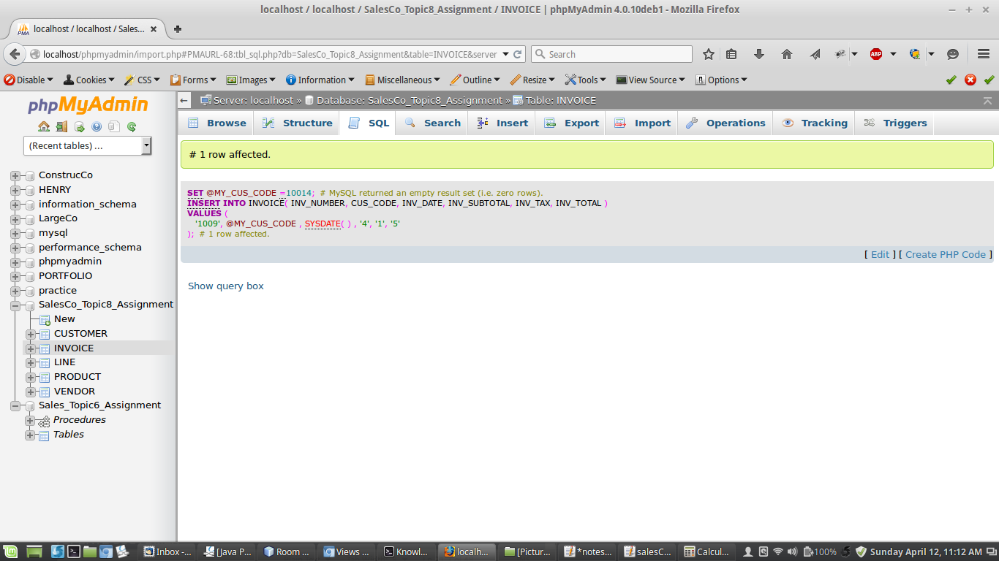

**INVOICE PRINT VIEW AFTER INSERT**

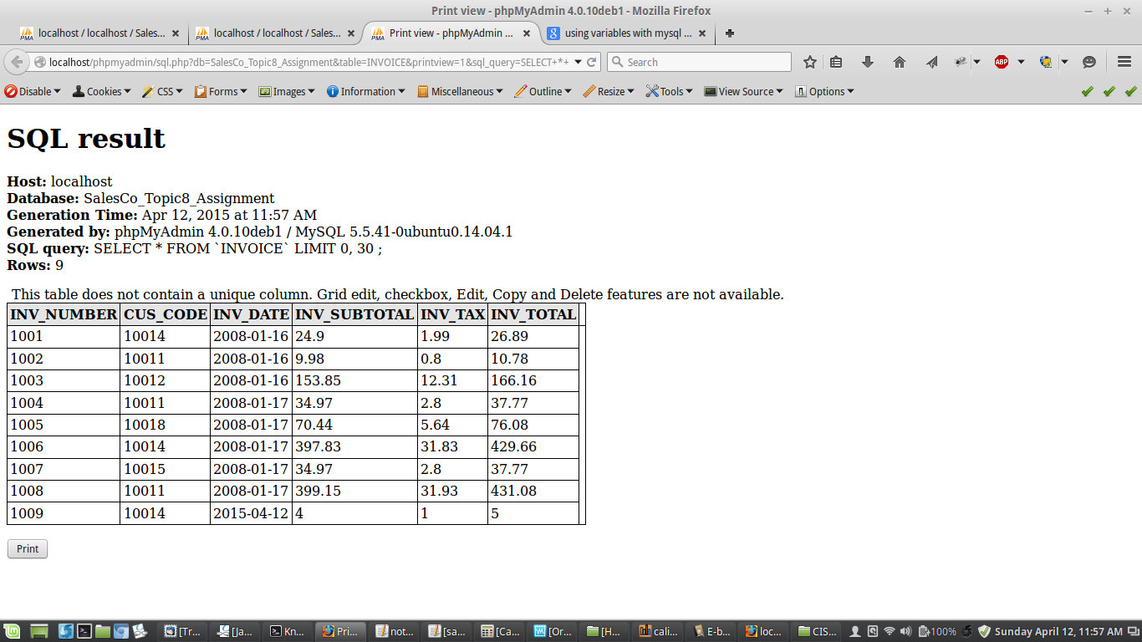

**THE TRIGGER CREATED**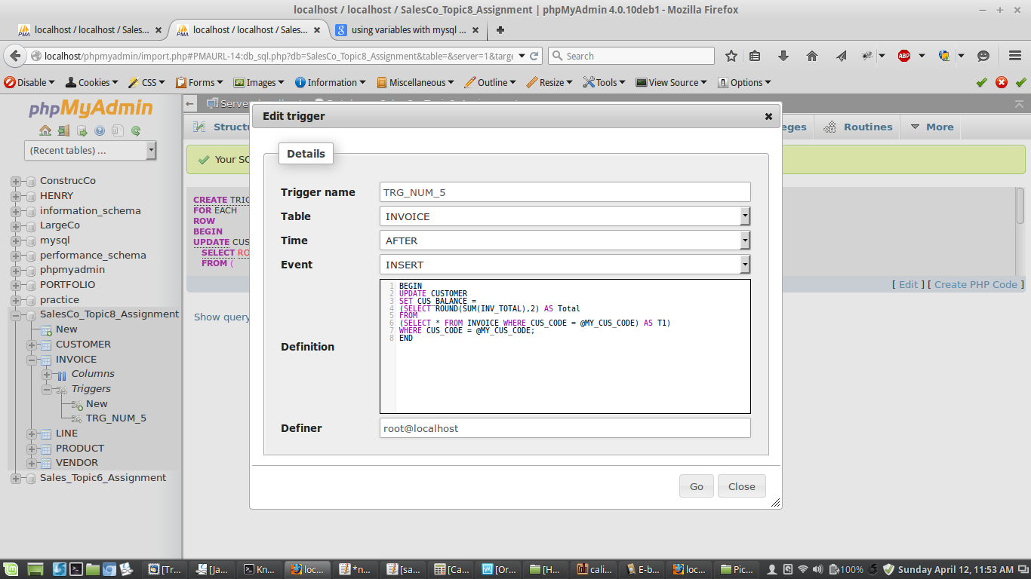

**CUSTOMER TABLE BEFORE TRIGGER OCCURS**

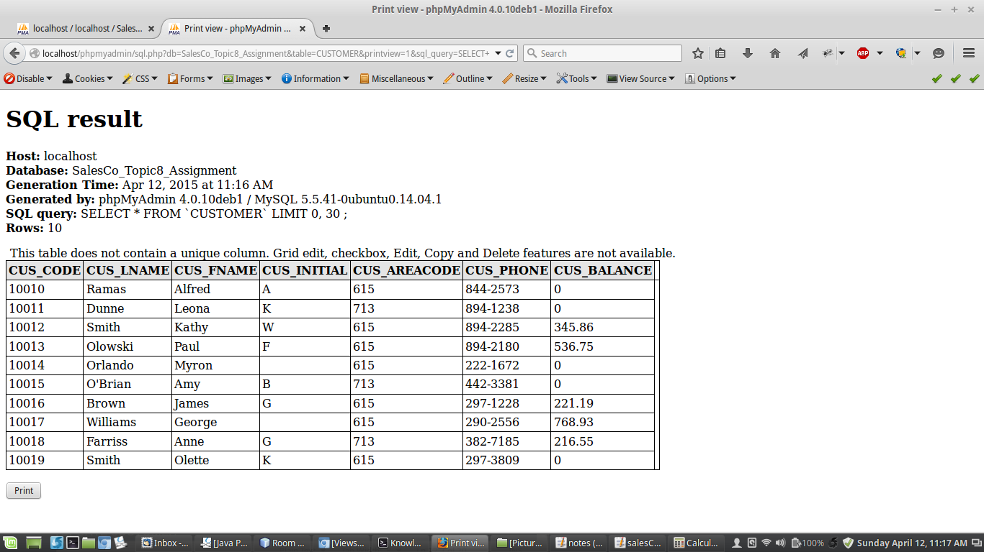

**CUSTOMER TABLE AFTER TRIGGER OCCURS**

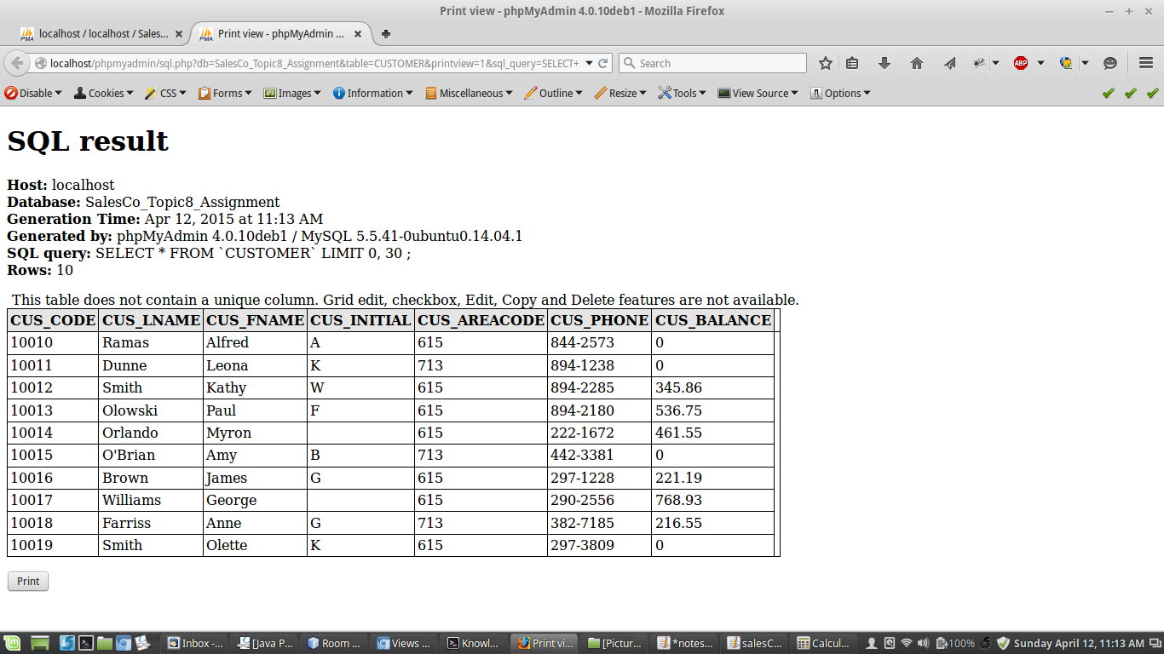

**SYNTAX USED FOR PART 5**

|  |
| --- |
| -- Insert SQL to trigger with variable for customer code  SET @MY_CUS_CODE = 10014;  INSERT INTO INVOICE(INV_NUMBER, CUS_CODE, INV_DATE, INV_SUBTOTAL, INV_TAX, INV_TOTAL) VALUES  ('1009',@MY_CUS_CODE,SYSDATE(), '4', '1', '5');  -- Sets the trigger to update the customer balance based on customer code  CREATE TRIGGER TRG_NUM_5 AFTER INSERT ON INVOICE  FOR EACH ROW  BEGIN  UPDATE CUSTOMER  SET CUS_BALANCE =  (SELECT ROUND(SUM(INV_TOTAL),2) AS Total  FROM  (SELECT * FROM INVOICE WHERE CUS_CODE = @MY_CUS_CODE) AS T1)  WHERE CUS_CODE = @MY_CUS_CODE;  END;  /  -- According to the original invoice amounts and the new inserted invoice amount  26.89 + 429.66 + 5 = 461.55 |

**#6 Create a Stored Procedure, for the SaleCo2 database, that will:**

1. **Delete a Customer from the Customer table by accepting the Cust_Code as a procedure parameter when you CALL the procedure to be executed in the SQL window/tab within PhP MySQL..**
2. **Delete all associated rows for this Customer in the tables  Invoice and Line.**

**SEE BELOW…**

**CUSTOMER TABLE AFTER INSERT TO TEST PROCEDURE**

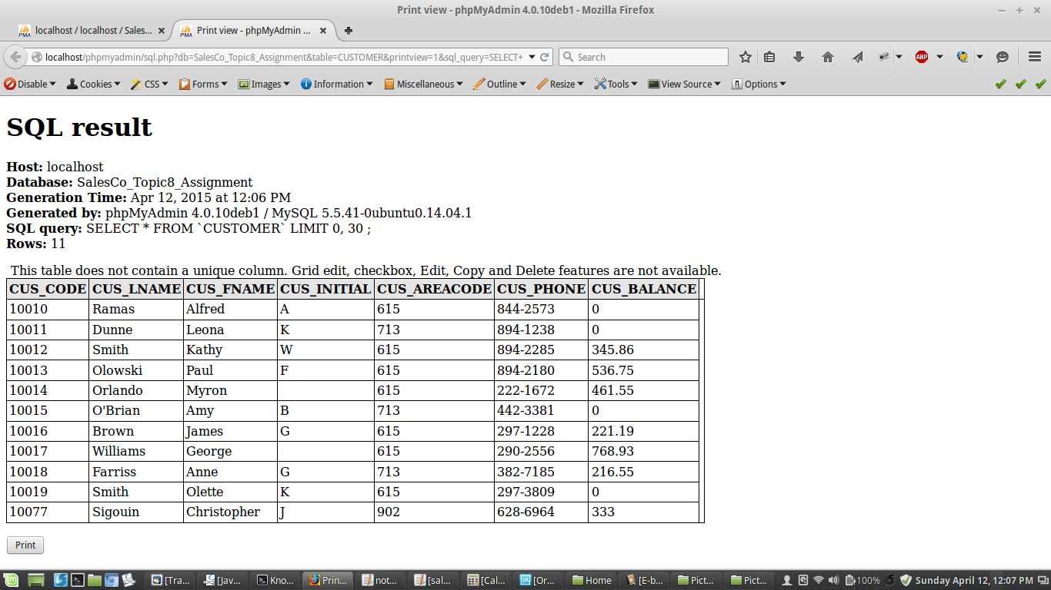

**INVOICE TABLE AFTER INSERT….**

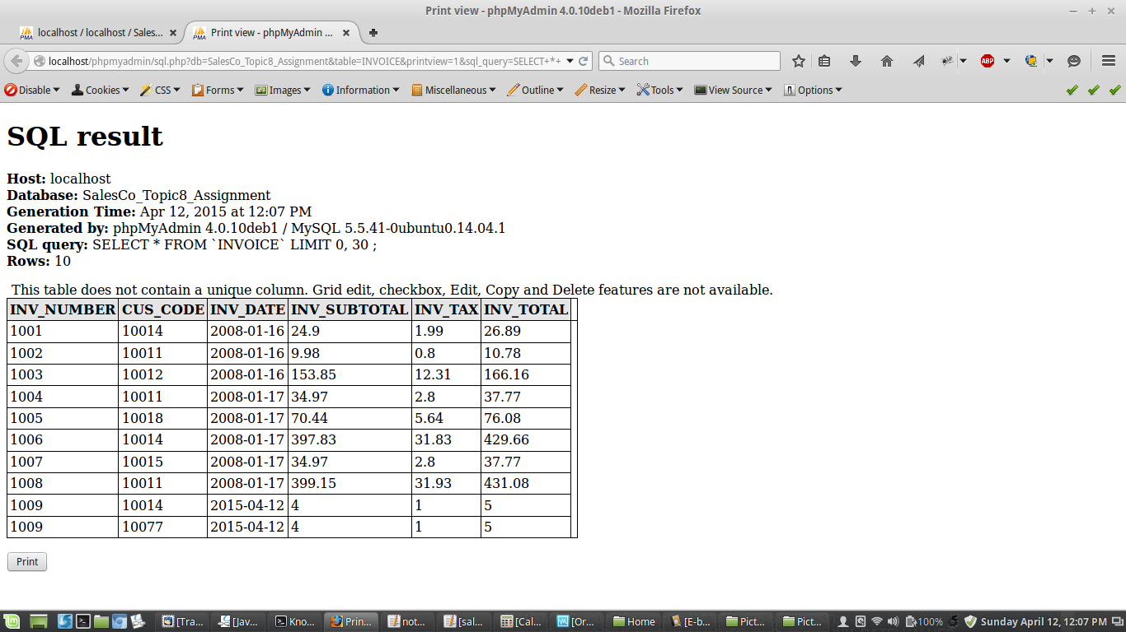

**LINE TABLE AFTER INSERT…**

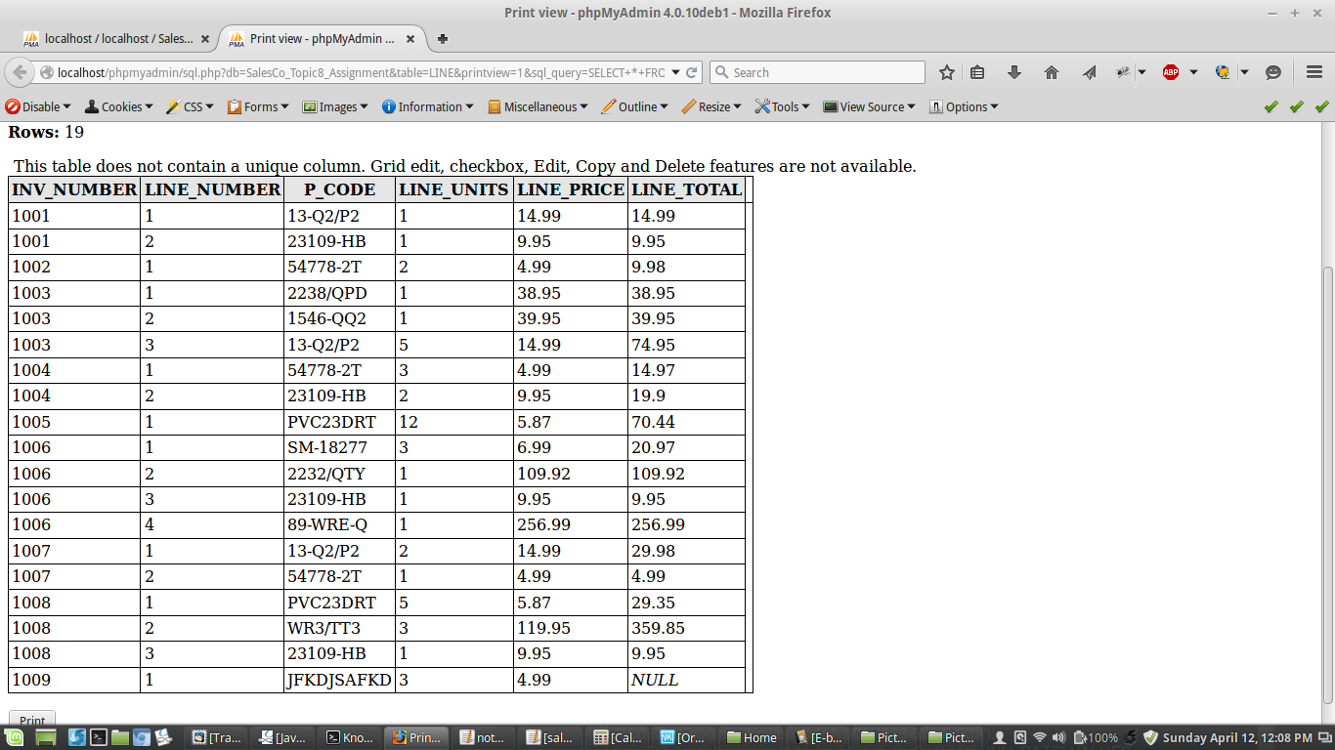

**PROCEDURE CREATED**

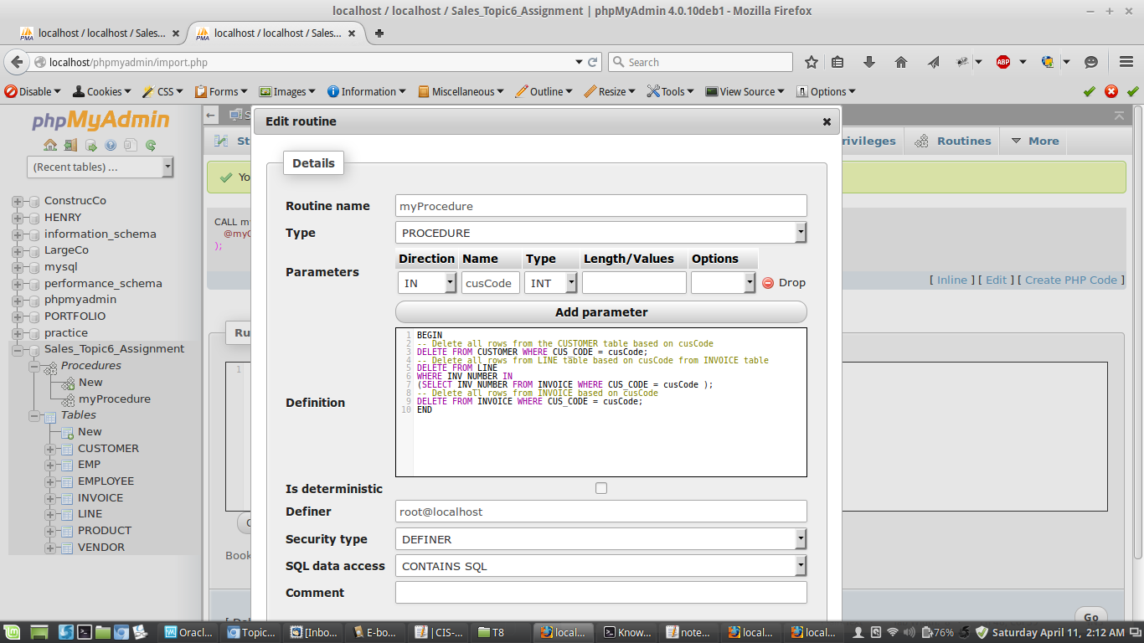

**CUSTOMER TABLE AFTER PROCEDURE CALL**

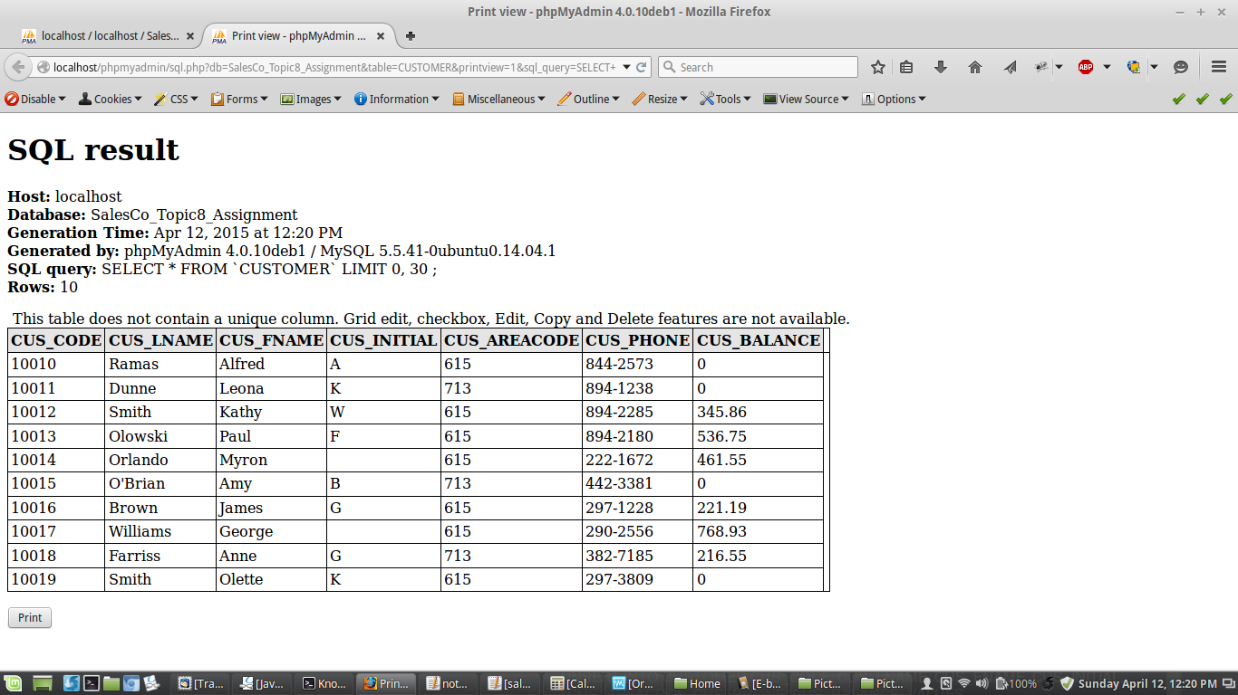

**INVOICE TABLE AFTER PROCEDURE CALL….**

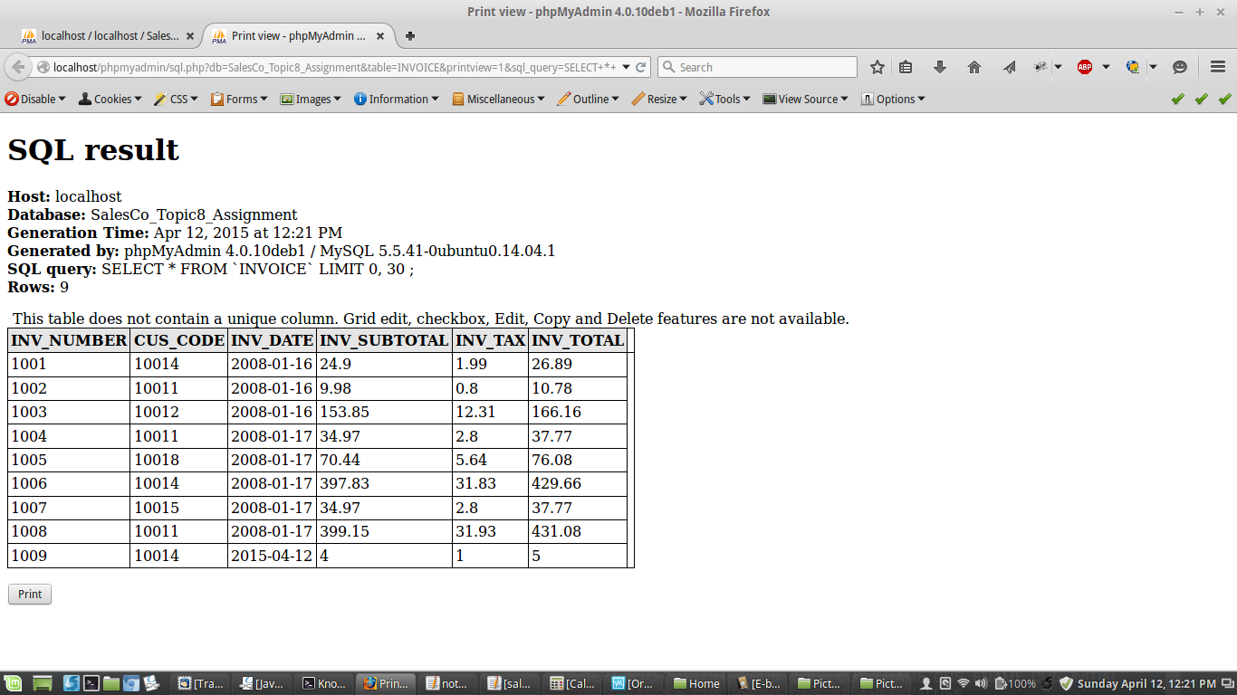

**LINE TABLE AFTER PROCEDURE CALL…**

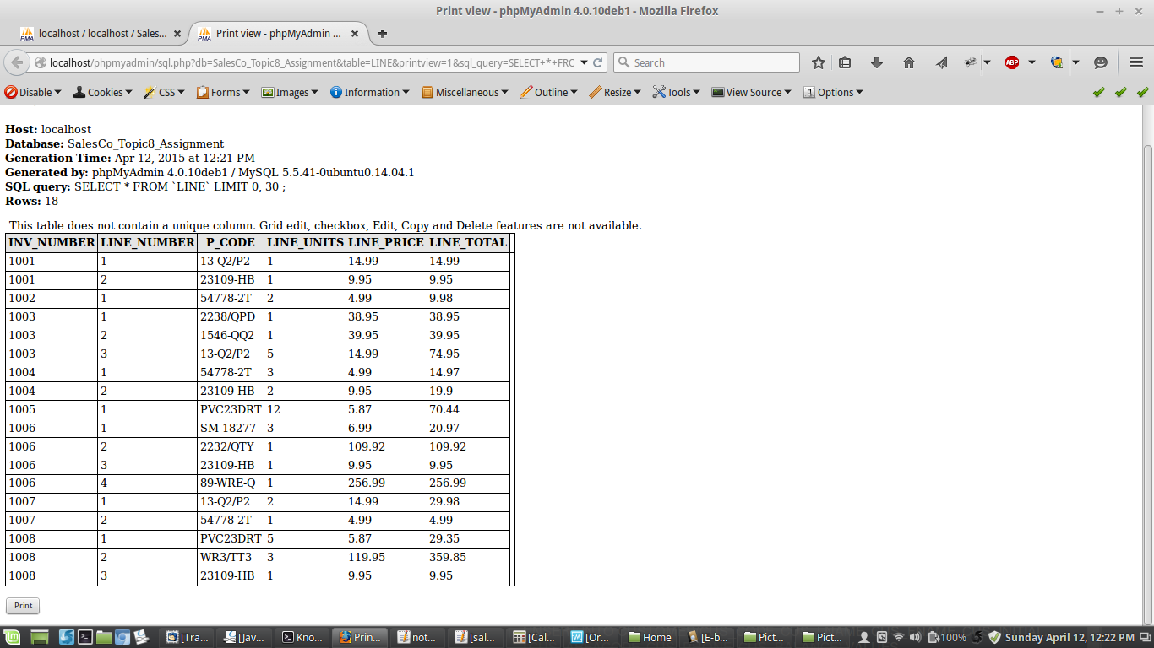

**SYNTAX USED FOR PART 6**

|  |
| --- |
| -- Creates the stored procedure  CREATE PROCEDURE myProcedure (IN cusCode INT)  BEGIN  -- Delete all rows from the CUSTOMER table based on cusCode  DELETE FROM CUSTOMER WHERE CUS_CODE = cusCode;  -- Delete all rows from LINE table based on cusCode from INVOICE table  DELETE FROM LINE  WHERE INV_NUMBER IN  (SELECT INV_NUMBER FROM INVOICE WHERE CUS_CODE = cusCode );  -- Delete all rows from INVOICE based on cusCode  DELETE FROM INVOICE WHERE CUS_CODE = cusCode;  END;  /  -- Run inserts to create a customer for deletion by the procedure with code 10077  INSERT INTO CUSTOMER(CUS_CODE, CUS_LNAME, CUS_FNAME, CUS_INITIAL,  CUS_AREACODE, CUS_PHONE, CUS_BALANCE) VALUES  ('10077','Sigouin','Christopher','J','902','628-6964','333');  INSERT INTO INVOICE(INV_NUMBER, CUS_CODE, INV_DATE, INV_SUBTOTAL, INV_TAX, INV_TOTAL) VALUES  ('1009',10077, SYSDATE(), '4', '1', '5');  INSERT INTO LINE(INV_NUMBER, LINE_NUMBER, P_CODE, LINE_UNITS, LINE_PRICE) VALUES  ('1009','1','JFKDJSAFKDA','3','4.99');  -- Run the procedure to delete the inserts that were executed  CALL myProcedure(10077); |